New Patient Intake Form
PLEASE HAVE YOUR DRIVERS LICENSE AND AUTO INSURANCE CARD AVAILABLE THANK YOU
Patient Information
Name_______________________________Date of Birth ________Date_________Date of Accident________
Address_______________________________________City/State______________________Zip___________
Best Phone ____________________Email Address (for clinic news)__________________________________
Gender________________Marital Status________________________ Social Security #_________________
Occupation_______________________Company Name___________________Work Phone______________
Spouse/Gaurdian’s Name_____________________________________Occupation_____________________
Contact Name, In Case of Emergency_______________________________Phone______________________

Your Auto Insurance
Insurance Company__________________________________________Policy#_________________________
Insured’s Name__________________________________MedPay Claim #_____________________________
Adjustor’s Name________________________________________Phone#_____________________________

At-Fault Auto Insurance
Insurance Company__________________________________________Policy#_________________________
Insured’s Name _________________________________________Claim #_____________________________
Adjustor’s Name________________________________________Phone#_____________________________

Attorney Information
Attorney’s Name________________________________________Phone_________________________
Address_________________________________________ Email ______________________________

Witness: _____________________________________ Date: _______

Assignment of Benefits and Release of Records
I authorize my primary auto insurance company or tertiary auto insurance company to make payments to Denver Chiropractic, LLC, Antero Medical Group, PC and Physical Rehabilitation Specialists, PC for all services provided by Denver Chiropractic, LLC, Antero Medical Group, PC and Physical Rehabilitation Specialists, PC. I give permission for my doctors and any holder of my medical records to be released by Denver Chiropractic, LLC, Antero Medical Group, PC and Physical Rehabilitation Specialists, PC. I will provide all information needed to process my claims in a timely manner.

Consent to Examination & Treatment
I, the patient named below, hereby request and consent to the performance of chiropractic examinations, adjustments, dry needling, Graston technique, active release technique, flexion-distraction therapy, moist heat, electrotherapy, ultrasound, kinesio taping, and other procedures on me (or the patient named below, for whom I am legally responsible) by the licensed doctors at Denver Chiropractic, LLC. I understand and I am informed that, in the practice of chiropractic there are some risks to examination and treatment including, but not limited to, soreness, fractures, disc injuries, strokes, dislocations, sprains, pneumothorax, increased symptoms, or no improvement. I do not expect the doctor to be able to anticipate and explain all risks and complications, and I wish to rely on the doctor to exercise judgment during the course of the procedure which the doctor feels at the time, based on the facts then known, is in my best interest. I further acknowledge that no guarantees or assurances have been made to me concerning the results intended from the treatments. I intend this consent form to cover the entire course of treatment of my present condition and for any future conditions for which I seek treatment. I understand that I may refuse treatment at any time and that I am responsible for my healthcare choices.

I also consent to have Antero Medical Group, PC and their employees to evaluate and treat the patient named below for medical complaints and illnesses. This includes taking of medical information, evaluation by physical examination, obtaining bodily fluids for laboratory testing, obtaining of X-rays for diagnosis, the administration of medications for treatment, and any other treatment or evaluation that may be necessary. If at any time, I do not wish to have these services rendered, I may state so and they will not be provided. All of my information will remain confidential. I acknowledge I have been offered a copy of Antero Medical Group, PC’s Notice of Privacy Practice. I hereby consent to evaluation and treatment by Physical Rehabilitation Specialists, PC and/or its clinical staff for either my

I hereby consent to evaluation and treatment by Physical Rehabilitation Specialists, PC and/or its clinical staff for either my
dependent or myself. I understand there are certain risks associated with any examination and treatment and those risks have
been presented and explained to me.

Our Privacy Policy
The office of Denver Chiropractic, LLC, Antero Medical Group, PC and Physical Rehabilitation Specialists, PC is committed to upholding the security and confidentiality of personal information that you provide to us. We take our responsibility of safeguarding your information very seriously. We do not share or sell patient information with anyone outside our office without your written consent. This policy covers information including personal, financial, or health information about a consumer or customer relationship. I hereby authorize that my records of evaluation and treatment with the office of Denver Chiropractic, LLC may be forwarded to referring physicians, specialists, or therapists who are also involved in my healthcare.

I understand and have read the assignment of benefits and release of records, the consent to examination and treatment and our privacy policy
Signature: _________________________________ Date: _____________________________
Release of Medical Information
1. I give permission for Antero Medical Group, PC, Denver Chiropractic LLC and Physical Rehabilitation Specialists, PC to release information, verbal or written, contained in my medical record, and other related information to my insurance company, attorney, employer, school, related healthcare provider, assignee and/or beneficiaries and all other related personas as it relates to my treatment.
2. I authorize Antero Medical Group, PC, Denver Chiropractic, LLC and Physical Rehabilitation Specialists, PC to obtain medical records and/or professional information from my physician or other medical professional, attorney and insurance company as it relates to my treatment and claim.
3. If you have never been adjusted you may be sore after your treatment. This soreness is similar to a long hike or a good workout type of soreness. Soreness can be a good response, as is the soreness you get after a good workout.

I understand and have read the consent to treatment and examination, our privacy policy, and information regarding your healing.
Signature ________________________________________________________________Date__________
Consent for Release of Information
By checking this box, I agree to be contacted and that voicemail may be left on my phone by an Antero Medical Group, PC, Denver Chiropractic, LLC and Physical Rehabilitation Specialists, PC, patient liason or Physician.
CONSENT FOR THE TRANSMISSION OF INFORMATION: By checking this box, I give Antero Medical Group, PC, Denver Chiropractic, LLC and Physical Rehabilitation Specialists, PC, permission to communicate any future medical information to me by the telephone and/or email provided earlier in this document.
By signing below, I understand this agreement to be between Antero Medical Group, PC, Denver Chiropractic, LLC and Physical Rehabilitation Specialists, PC, AND THE UNDERSIGNED.

History of Accident

1. Location of Accident City/State_________________________Street/s__________________________
2. Approx. Time of Day____________ Weather Conditions?_________________ Seat Belt On?________
3. Any Passengers?________Names________________________________________________________
4. Year/Make/Model of Your Vehicle _______________________ Other Vehicle_____________________
5. Your Approx. Speed at Impact? __________________________ Other Vehicle_____________________
6. Your Head Position at Impact? (turned L/R, up/down)_____ Were You Aware of Impending Impact?___
7. Drivers Feet Position at Impact? (brake, clutch, both, gas, etc.) _________________________________
7. Witness Names? _________________________________Were Photographs Taken? _______________
8. What Part of Your Car Was Damaged? _____________________ Other Car?______________________
9. Description of the Accident 10. Diagram of the accident
_________________________________________
_________________________________________
_________________________________________
_________________________________________
_________________________________________
11. Estimate for repair of your car_____________
12. Did either insurance company refer you to the place where you got the estimate?________________
13. Were you paid for the vehicle damage?________How much?__________

Regarding Your Healing
1. Auto injuries produce wide spread damage and thus take more visits then an average case of non-auto related acute neck or back pain. On average, a typical whiplash injury will require approximately 26 visits for resolution of the injuries. Everyone responds to treatment slightly different which may shorten or lengthen the amount of total visits needed.
2. Neck or back pain usually fluctuates, meaning that you will have flare ups along the course of your healing. It is expected to have aggravations of your injuries.
3. If you have never been adjusted you may be sore after your treatment. This soreness is similar to a long hike or a good workout type of soreness. Soreness can be a good response, as is the soreness you get after a good workout.

I understand and have read the release of medical information, consent for doctor-patient communications, and information regarding your healing.
Signature ________________________________________________________________Date_______
History of Accident
1. Location of Accident City/State___________________________Street/s____________________________
2. Approx. Time of Day______________Weather Conditions?__________________Seat Belt On?__________
3. Any Passengers?________Names____________________________________________________________
4. Year/Make/Model of Your Vehicle_________________________Other Vehicle_______________________
5. Your Approx. Speed at Impact?____________________________Other Vehicle______________________
6. Your Head Position at Impact?(turned L/R, up/down)____________You Aware of Impending Impact?_____
7. Drivers Feet Position at Impact? (brake, clutch, both, gas, etc.)____________________________________
7. Witness Names?__________________________________Photographs Taken?______________________
8. What Part of Your Car Was Damaged?______________________________Their’s____________________
9. Description of the Accident 10. Diagram of the accident
_________________________________________
_________________________________________
_________________________________________
_________________________________________
_________________________________________
_________________________________________
_________________________________________
_________________________________________
_________________________________________
_________________________________________
11. Cost of Repairing Your Car_________________
12. Did either insurance company refer you to the place where you got the estimate?___________________
13. Were you paid for the vehicle damage?________How much?__________
Injuries, Impairments, & Damages
Please mark any of the symptoms you have experienced SINCE the accident
__Headaches | __Dizziness | __Difficulty Concentrating
__Long Term Memory Loss | __Short Term Memory Loss | __Amnesia
__Loss of Consciousness at Scene | __“Blackouts” Since Collision | __Forgetting ATM or other Numbers
__Reading Problems | __Writing Problems | __Typing Problems
__Apathy | __Irritability | __Sleep Disturbances
__Personality Changes | __Emotional Difficulties | __Relationship Difficulties
__Blurred Vision | __Photophobia (Sensitivity to Light) | __Vision Changes
__Intolerance to Alcohol | __Intolerance to Heat | __Intolerance to Cold
__Impaired Comprehension | __Impaired Learning | __Attention Impairment
__Loss of Libido | __Missing Periods of Time | __Speech Difficulties
__Concussion in Collision | __Nausea | __Vomiting
__Extreme Thirst Since Collision | __Fatigue | __Menstrual Irregularities
__Tinnitus (Ringing of Ears) | __Noise Intolerance | __Loss of Coordination
__Bumping Into Objects in View | __Loss of Balance | __Fluid in Ears
__Hearing Loss | __Vertigo (Spinning Sensation) | __Increased Symptoms in Crowds
__Anxiety | __Depression | __Change in Personality
__Flashbacks to Accident Scene | __Intrusive Thoughts of Accident | __Nightmares Since Collision
__Unusual Behavior Since Collision | __Social Withdrawal | __Panic Attacks
__Thoughts of Death /Suicide | __Weight Loss / Gain _____lbs | __Loss of Taste / Smell
__Blackouts with Neck Movements | __Dizziness with Neck Movements | __“Clunk” Sound w/ Moving Neck
__Jaw Pain | __Clicking in Jaw | __Pain with Chewing

Numbness / tingling / weakness in arms? | Yes | No | R | L | Level(s)__________________________
Numbness / tingling / weakness in legs? | Yes | No | R | L | Level(s)__________________________
Did the Seatbelt bruise you? _______Where? ________

Injuries, Impairments, & Damages Cont.

Where was headrest located before impact? __Upper Back __Mid Neck __Mid Head __Upper Head __None

Did your head or body strike anything inside the car? __Yes |  |  |  | __ No (If yes, what?) ______________________
Were any of your items displaced? __Yes |  |  |  | __ No (If yes, what?) ______________________
Did you lose consciousness? __Yes |  | __No | If Yes (approximate length of time) ___________
Did your Airbag(s) Deploy? __Yes | __No |  | Did your seats break? __Yes __No
Were you transported via EMS or Ambulance? ___ Yes ___ No (If yes, please provide)
Name of Ambulance Company | Date | From | To
1._______________________________________________________________________________________
Please list any Emergency Room, Hospitalizations, Outpatient Surgeries (Related only to this Collision):
Physician Facility Surgery / Problem
1._______________________________________ 2. ______________________________________________
3._______________________________________ 4. ______________________________________________
Please list any Treating Physicians / Specialists / Therapists (Related only to this Collision):
Provider Facility Address Phone
1._______________________________________________________________________________________
2._______________________________________________________________________________________
3._______________________________________________________________________________________
Is there anything you are currently unable to do, that you were able to do prior to the accident?
_________________________________________________________________________________________
_________________________________________________________________________________________

Injuries, Impairments, & Damages Cont.
Impaired Activities
Circle all activities which have been impaired in any way by the accident in question:
Daily Activities
bathing/showering | bending | brushing teeth | Dressing | driving car
vacationing | dining out | movie going | standing | sitting
sexual relations | lifting | church events | child care | Religious (bending/kneeling)
washing hair | eating | Moving | reading | shaving
shopping | watching TV | sleeping | traveling | social events
Domestic Activities (Activities within the Home)
Bending | Cooking | ironing | housecleaning | laundry
Washing Dishes | vacuuming | dusting | interior painting | decorating
Household Activities (Activities outside the Home)
Trimming bushes | Gardening | Tree trimming Mowing Lawn |  | Yard Work
Exterior painting | Car Washing | Landscaping | House Maintenance | Farm activities
Work Activities
Sitting | standing | lifting | using telephone | computer work
Reading | bending | typing | writing | child care
Hobby Activities
Aerobic exercise | archery | backpacking | bowling | badminton
baseball | basketball | basketry | bicycling | Boxing
card playing | camping | dancing | fencing | Fishing
flying | football | gardening | golf | Handball
gymnastics | health clubs | hockey | hunting | Judo
horseback riding | ice skating | Karate | painting | Yoga
jogging/running | photography | raquetball | rafting | sailing
mountain climbing | sewing | snow skiing | swimming | walking
musical instruments | volleyball | water skiing | water sports | weight lifting
Activities which you have performed despite pain, due to financial, family or personal needs (Duties Under Duress):
__Work __Education __Domestic (Activities within the Home) __Household (Duties outside the Home)
_________________________________________________________________________________________
Past Motor Vehicle Accidents, Workers Compensation Claims, or other claims of Any Sort:________________
______________________________________________________________________________
__________________________________________________________________________________________
__________________________________________________________________________________________
__________________________________________________________________________________________

Injuries, Impairments, & Damages Cont.
Describe your Headache pain: ___ Sharp ___ Dull ___ Aching ___ Stabbing ___ Cramping
Are your symptoms (please check): _____Constant ____Come and go
Onset: Did the headaches start? ___ Before accident ___ At time of accident ___After accident
How severe are your headaches on a scale of 1 to 10? _____
What makes your headaches worse? __Washing __Dressing __Grooming __Lifting __ Sitting __Standing

Describe your Neck pain: ___ Sharp ___ Dull ___ Aching ___ Stabbing ___ Cramping
Are your symptoms (please check): _____Constant ____Come and go
Onset: Did the headaches start? ___ Before accident ___ At time of accident ___After accident
How severe are your neck pain on a scale of 1 to 10? _____
What makes your neck pain worse? __Washing __Dressing __Grooming __Lifting __ Sitting __Standing
Do you experience any numbness, tingling or weakness into your arms? __________________

Describe your Back pain: ___ Sharp ___ Dull ___ Aching ___ Stabbing ___ Cramping
Are your symptoms (please check): _____Constant ____Come and go
Onset: Did the back pain start? ___ Before accident ___ At time of accident ___After accident
How severe is your back pain on a scale of 1 to 10? _____
What makes your back pain worse? __Washing __Dressing __Grooming __Lifting __ Sitting __Standing
Do you experience any numbness, tingling or weakness into your legs? ___________________

Describe your Extremity pain: ___ Sharp ___ Dull ___ Aching ___ Stabbing ___ Cramping
Are your symptoms (please check): _____Constant ____Come and go
Onset: Did the extremity pain start? ___ Before accident ___ At time of accident ___After accident
How severe are your extremity pain on a scale of 1 to 10? _____
What makes your extremity pain worse? __Washing __Dressing __Grooming __Lifting __ Sitting __Standing

Injuries, Impairments, & Damages Cont.
Describe any cognitive issues you are having and give life examples where appropriate:
Forgetfulness: ___ Yes ___No ______________________________________________________________________
Confusion: ___ Yes ___No _________________________________________________________________________
Anxiety: ___ Yes ___No ___________________________________________________________________________
Sadness: ___ Yes ___No ___________________________________________________________________________
Anger: ___ Yes ___No ____________________________________________________________________________
Sleep Disturbance: ___ Yes ___No___________________________________________________________________
Suicidal thoughts: ___ Yes ___No ___________________________________________________________________
Homicidal thoughts: ___ Yes ___No __________________________________________________________________
List any medical problems you have: _________________________________________________________________

Have you had any major surgeries? ___ Yes ___No (if yes please list surgery and approximate date(s)
____________________________________________________________________________________
List any medications you are currently taking: _____________________________________________
______________________________________________________________________________________
Do you have any drug allergies? ___ Yes ___No (if yes please list)
______________________________________________________________________________________
Do you have severe illness in your family? (Heart disease, blood clot, diabetes, etc..) ___ Yes ___No
Please List:_____________________________________________________________________________

Do you: use tobacco? ___ Yes___No -- Alcohol? ___ Yes ___No -- Illicit Drugs?___ Yes ___No

Are you currently working? ___ Yes ___No What is your occupation? __________________________

Female patients:
Could you be pregnant? ___ Yes ___No – Are you breast feeding? ___ Yes ___No

Injuries, Impairments, & Damages Cont.

*Mark the areas on the diagram where you feel pain*
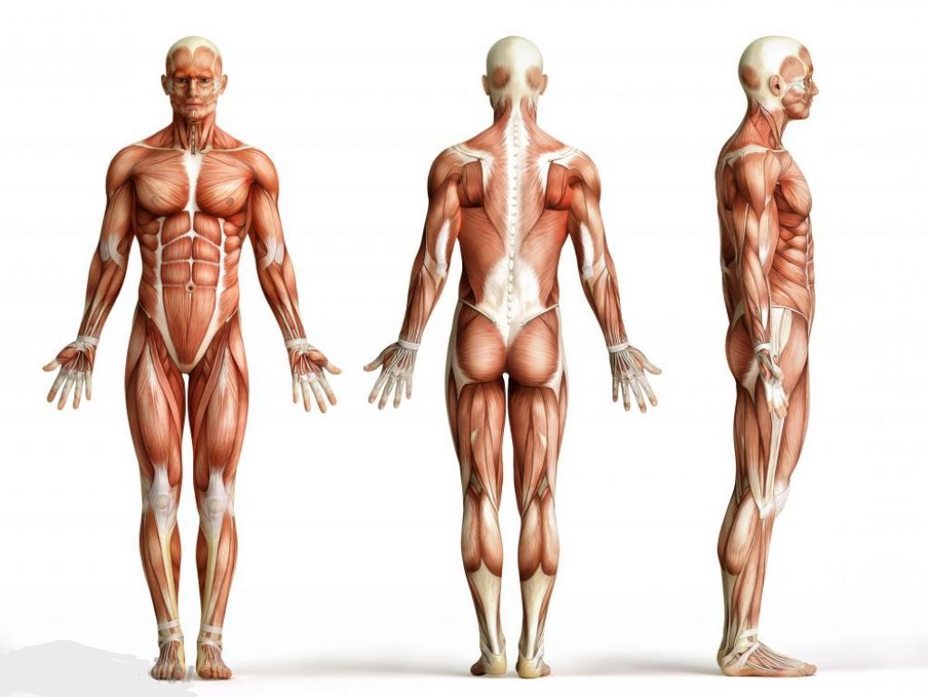

************************************ OFFICE USE ONLY *************************************

Vitals: T______ BP______/______ P_______ SaO2______

Denver Chiropractic, LLC Lien
TO: Denver Chiropractic, LLC
FROM: _________________________________
(Print Patient Name)
I hereby authorize and direct my attorney/tertiary insurance company, to pay directly to said health provider such sums as may be due and owing it for medical services rendered me by reason of my accident on ________________(date of accident) and to withhold such sums from the net proceeds of any settlement, judgment or verdict as may be necessary to adequately protect said health provider. Net proceeds means the gross amount recovered, less any attorney fees and costs. In exchange for receiving this lien, said health provider agrees to forego further collection efforts. I hereby further give a lien on my case to said health provider against any and all net proceeds of any settlement, judgment or verdict which may be paid to you, my attorney, or myself as the result of the injuries for which I have been treated or injuries in connection therewith. I further understand that such payment is not contingent on any settlement, judgment or verdict by which I may eventually recover said fee. This lien shall be irrevocable and shall be valid and enforceable out of the net proceeds of my settlement, judgment or verdict. I understand that if I discharge my attorney, I have an obligation to notify said health care provider in writing within 48 hours.
Please initial all statements below:
_____ I understand that I will be charged the full usual and customary prices for my medical care and not cash pay or insurance rates. I further understand that this is the amount I am expected to repay the provider. I further agree that this amount is reasonable.
_____ I agree that if, at any time, including prior to settlement, the provider finds it necessary to proceed against the patient to collect medical bills, the provider may do so.
_____ In the event of the receipt of funds and non-payment resulting in the institution of lien enforcement proceedings, I shall be responsible for the payment of all reasonable fees and costs, including attorney’s fees incurred by my medical providers in enforcing said lien.
_____ I fully understand that I am directly and fully responsible to said health provider for all medical bills submitted for services rendered me and that this agreement is made solely for said health provider’s additional protection and in consideration of awaiting payment.
___________ _____________________________
Date [PATIENT NAME]
We, the health provider, agree to the terms stated above.
_________________________________________________
By: Denver Chiropractic, LLC, / Owner: Dr. Trent Artichoker
___________
Date

